Kami Oster Design Document

Goals and Mission

Our mission is to provide free Adventist sermons from around the world to our viewers. We hope that you will be able to learn about the Bible in a whole new way from different speakers perspectives. Experience the kind atmosphere and God speaking to you through these pastors.

* What do we do? Provide free Adventist sermons from around the world.
* How do we do it? By teaching others about the Bible in a whole new way, from different speaker’s perspectives.
* Whom do we do it for? Our viewers.
* What value are we bringing? A kind, Godly atmosphere.

Audience Definition:

I believe that anyone from curious children that are around 8 to seniors that are around 80 will be able to use this website.

User Experience:

Who is your character?

An older pastor of a Church in Montana

What do they look like? Tall, with grey hair and eyes so light blue they look transparent.

What are they doing? He is a pastor trying to figure out how to connect with his younger audience.

What are they feeling? Frustrated because all the other sermon websites are too complex for him to understand.

Why are they accessing your site? So that he could share his sermon in a new way with his younger audience. When he finds the website, he is pleasantly surprised by the easy functionality. He quickly uploads his sermons and tells his congregation about the website. It sparks interest in the younger audience and they watch his sermons online.

Who is your character? A single, mother of three. Working full time at a subway in Virginia.

What do they look like? Average height, dark hair, and tan skin

What are they doing? Trying to find a way to keep the Sabbath even when they're too tired to make it too church.

What are they feeling? Exhaustion, yet determination to keep the Sabbath and be a good example to her children.

Why are they accessing your site? So that they can keep the Sabbath, but still be able to stay home and rest. She found this website while looking up her church’s online webcast. It quickly changed the way her children viewed going to church and they became excited to listen to the sermon each Sabbath.

Who is your character? A boy who's family doesn't believe in anything, so he doesn't either. He goes to a middle school in New York

What do they look like? Short with glasses and freckles.

What are they doing? Trying to figure out what to do because his family says that God doesn't exist, but he read some of the Bible and it seemed true. What are feeling? Confused about whether he should have a religion or not.

Why are they accessing your site? To try to learn more about who God is. When he found it, he watched some sermons that sparked his interest. He started reading what people thought about the sermons and slowly it started changing him. He gave his heart to Christ and started submitting prayer request so that he would have the strength to tell his family about Jesus. One day he had the courage to do so and they are now active members of the church.

Competitive Analysis:

Sermonsearch.com Sermoncentral.com Sermoncloud.com Sermonsearch.com

Features 1 poor; 10 good

free|3

Place to submit prayer requests|1

Easy layout |8

Place to post ideas|6

Different topics and languages |5

Adventist |3

Pros: has different topics Has Bible study guide Good layout

Cons: Not free can’t submit prayer requests or ideas, doesn’t have different languages, not many Adventist sermons

Sermoncentral.com Features 1 poor; 10 good

free| 10

Place to submit prayer request| 1

Easy layout| 6

Place to post ideas| 7

Different topics and languages|7

adventist|5

Pros: Free, has preaching help, has many topics

Cons: No place to submit prayers, no place to post ideas, many pop up ads not many languages not a lot of Adventist sermons

Sermoncloud.com

Features 1 poor; 10 good

free|7

Place to submit prayer requests|1

Easy layout| 6

Place to post ideas|5

Different topics and languages|10

adventist|8

Pros: you can write comments and "amen" videos has many languages and topics many Adventist sermons

Cons: there are limited sermons per month for free, it doesn't have a place to submit prayer requests, the layout is awkward, and some sermon categories have outdated sermons

Content and Functionality Requirements:

Content inventory:

My content will contain a place to submit prayer requests, and an area to write your ideas/beliefs about the sermon. All the sermons will be free and there will be a variety of Adventist sermons ranging from all different types of topics and languages. There will also be an amen button that will work like a like button. There will also be a place to search for different churches.

Site content

Submitted: a place to share inspirational stories, your beliefs, and prayer requests.

Sermons: you will be able to click a topic you want to study/ see a sermon about

Languages: You'll select the language you want and a variety of Sermons will pop up with the chosen language.

Map: Will have a place where you can put in your area code and churches near you will pop up.

Functional Requirements: easy to navigate, a search engine bar, different headings.

My functional requirements are that the website must be appealing to look at and easy to navigate. You should be able to easily find a sermon you’re looking for, or if you are a pastor you should be able to easily upload your sermons. There will be a place to search for anything in the website, and there will be different headings, where you will find different things in the website, such as a place to submit prayers, or a place where you can choose different sermon topics.

Site Structure:

4.1 Metaphors: My metaphor is going to be a church. There will be a search bar at the top, and when you search a topic, for example jealousy, all the sermons on jealousy will pop up in the pews. For the section of my website where the submissions of prayer request will be, there will be a mailbox. You will be able to send prayer request to us via the mailbox. You will also be able to send in sermons (if you’re a pastor/speaker) and receive sermons that the website thinks you might like through the mailbox; but for this you must be a member. (Which will be free of charge) I chose these metaphors because I felt like they would best represent my website and would make the most sense.

4.2 Site Structure:

iidd

Prayer

Requests

Search zip code or city

Search Language

Search topic

Send in & receive sermons

Your Religious ideas

Sermons

Submitted

Languages

Map

Homepage



Format 1

Format 2

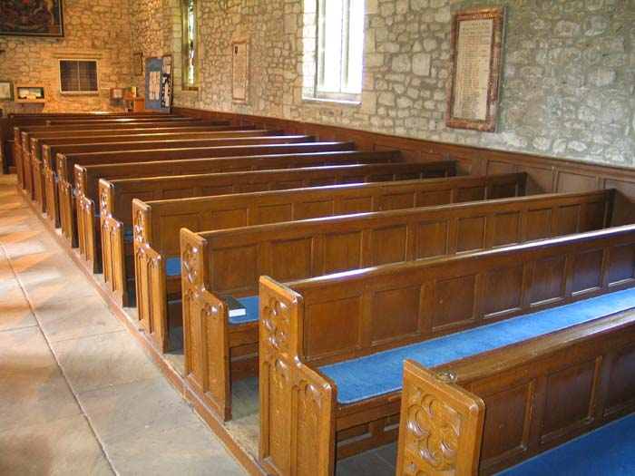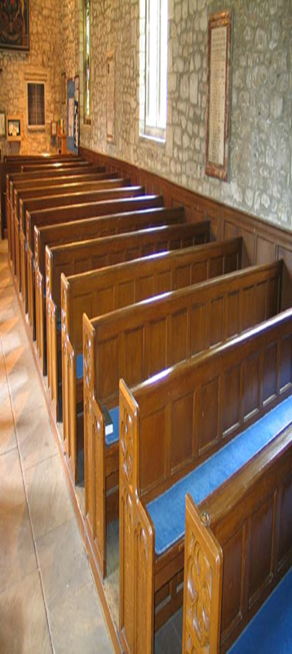

www.lettersfromGod.com

Submit

Mission

Find

Sermons

Home

Video on “The Second Coming”

By Pastor Smith

Greenbelt SDA Church 9/12/15



Mood Board